1. One of the most important points of being a good developer is to develop a testable app.
2. Mokito plays a key role to develop such testable apps.
3. **Agenda**:
   1. What is JUnit?
   2. What is Unit-Testing?
   3. How can you do mocking with Mokito?
   4. How to write great tests with Junit and Mokito?
4. 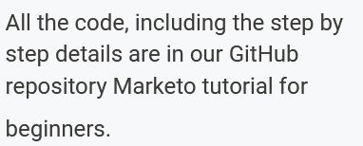
5. 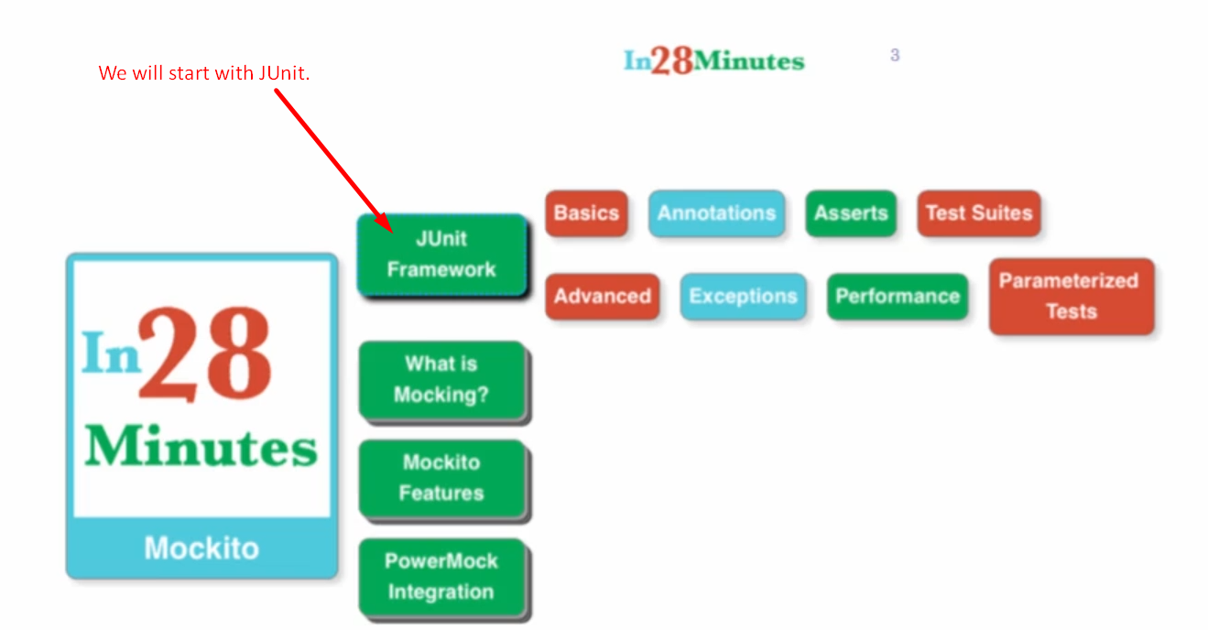
6. 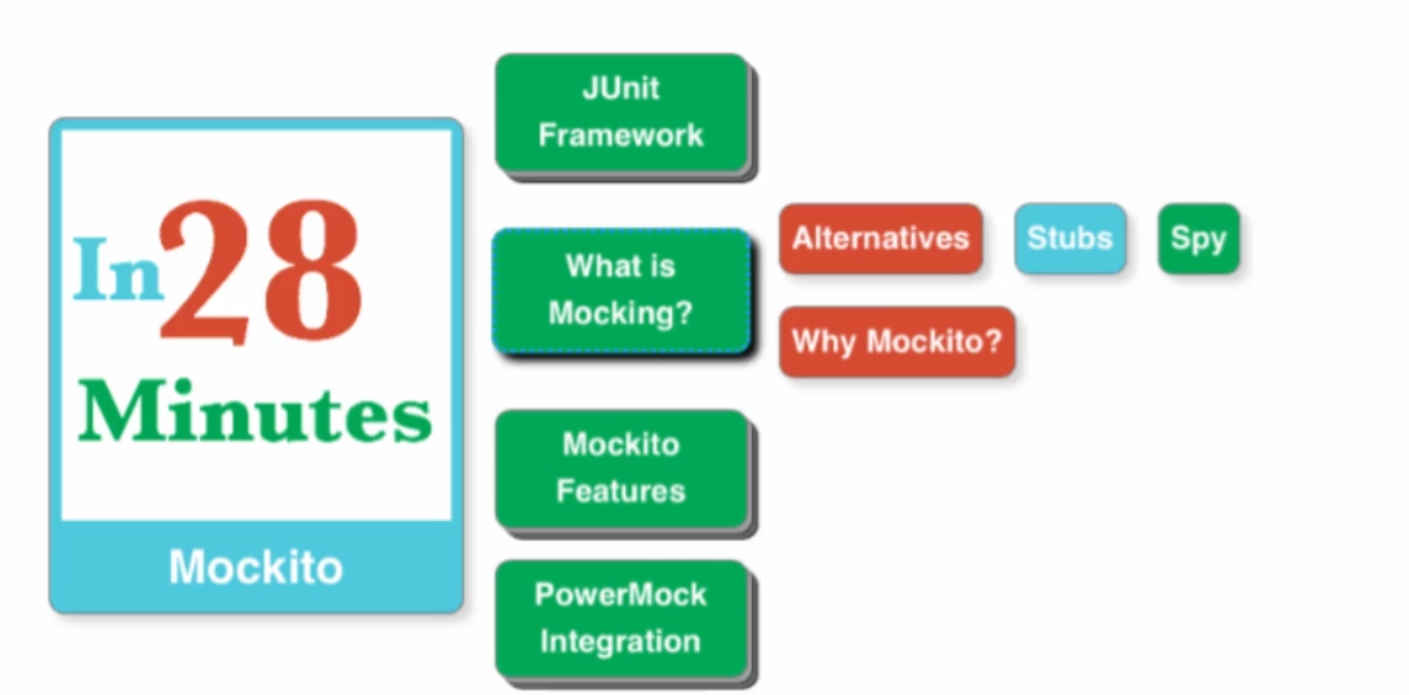
7. 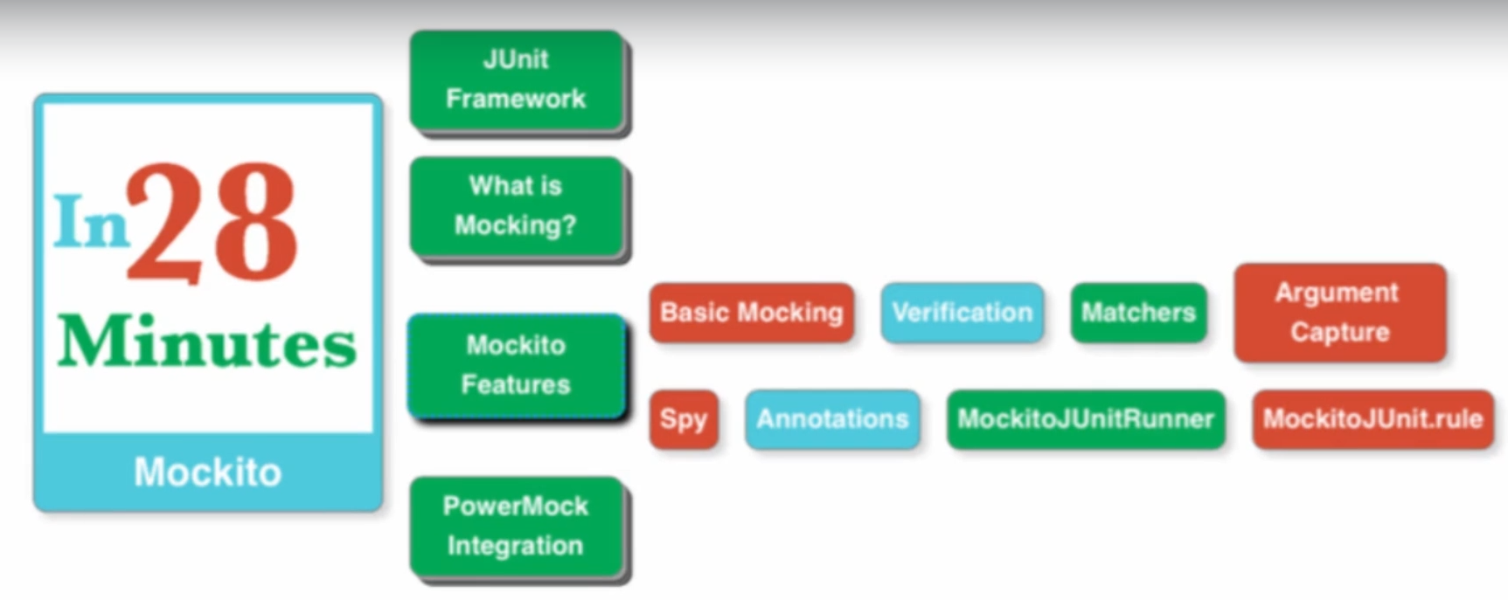
8. 